**Building a Mobile Application using mitappinventor**

**Project name:** Real-time River Water Quality Monitoring and Control system

**Team ID:** PNT2022TMID53593

**Design UI to display water Turbidity, pH values:**

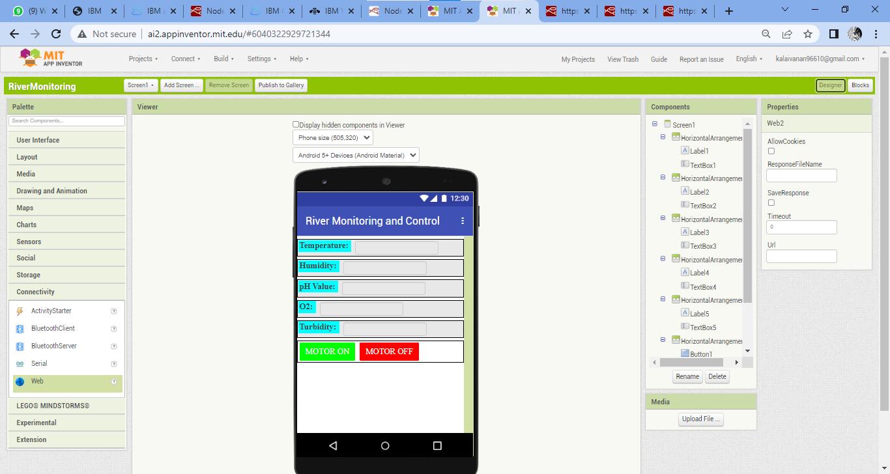

**MIT-App-Inventor Blocks:**

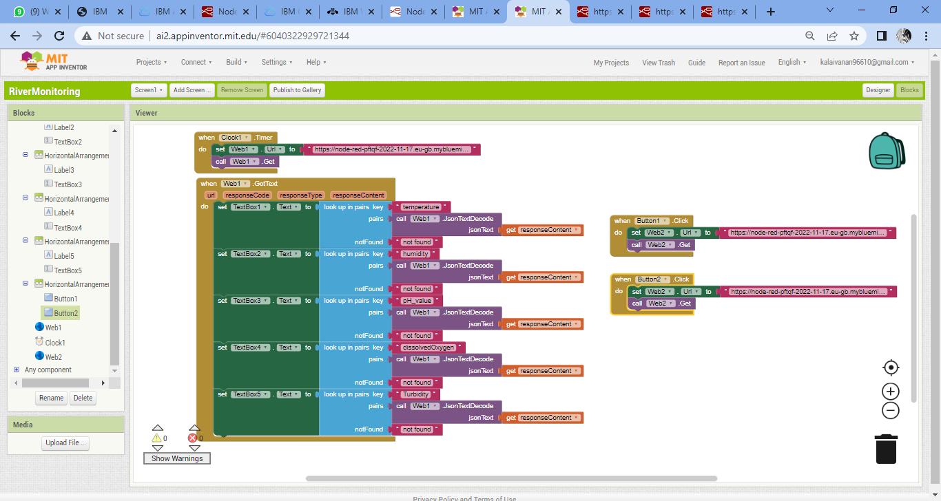

**Connecting to MIT A12 companion using QR code and Code:**

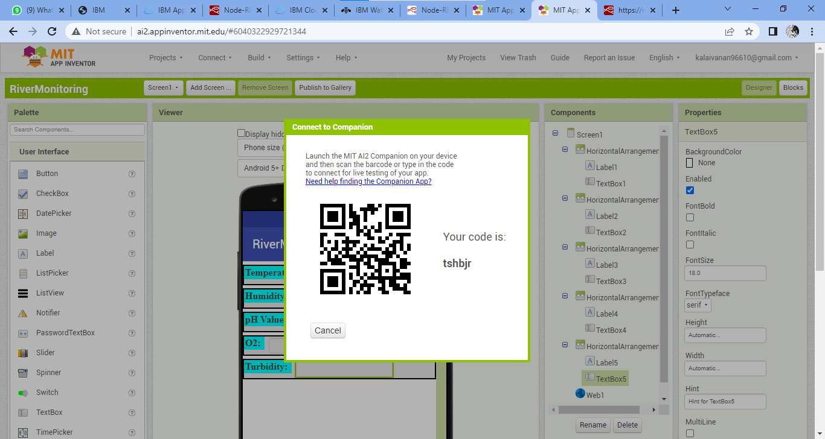

**Mobile Application Displaying Various Sensor Values:**

